How many times is each word/phrase said during the service?

God/Lord/Jesus _______________________________________
Elijah _______________________________________
How long? _______________________________________
Promise _______________________________________
Provide _______________________________________
Belief _______________________________________

What Scripture is the sermon from today? ___________________________________________

What phrase does Pastor Terry keep repeating during the sermon? (Hint: it’s a question)
_____________________________________________________________________________________

Definitions from Today’s Sermon
Monotheism: belief that there is _______________ god
Polytheism: belief that there are _______________ gods
Wavering: going back and forth between two beliefs or opinions; not deciding who to follow/serve

My Favorite Part of Service today was _____________________________________________________
Words/Things I didn’t understand:

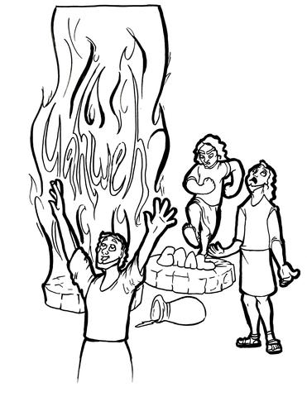

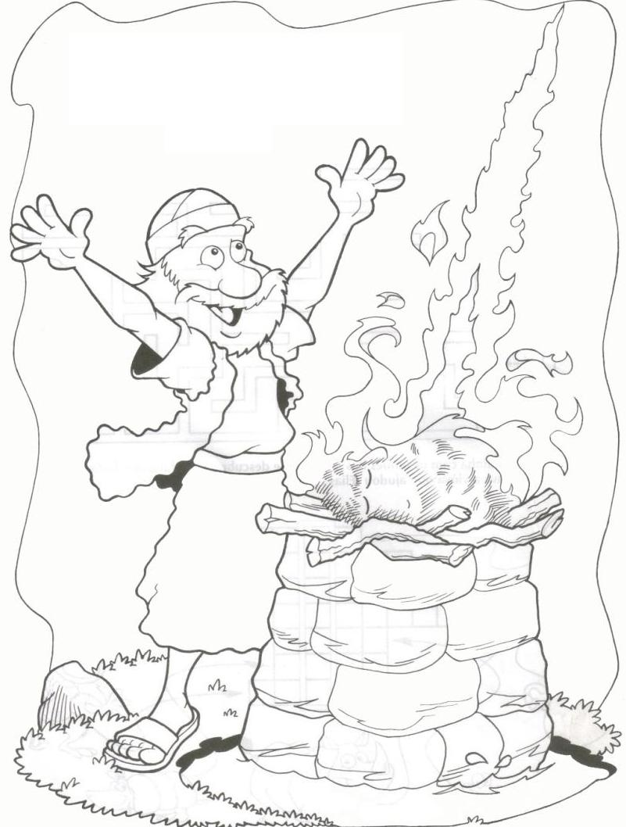
http://clipart-library.com/elijah-burning-altar-coloring-pages.html
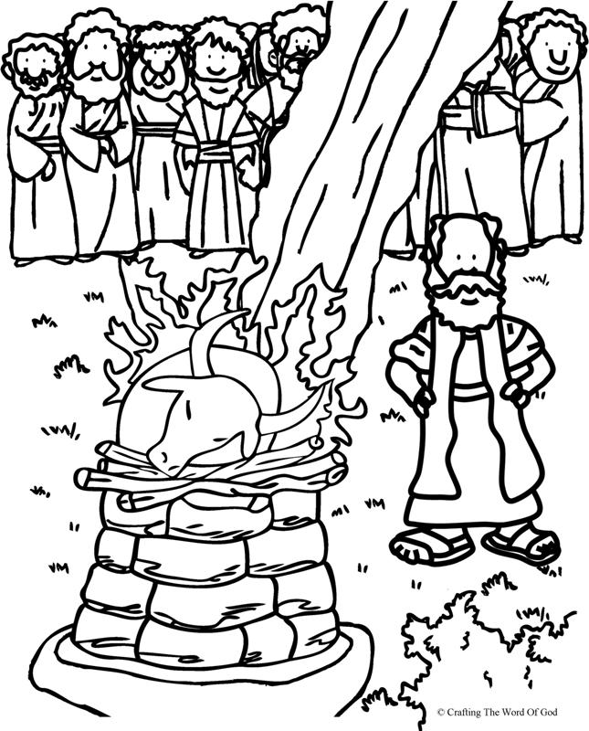
http://clipart-library.com/elijah-burning-altar-coloring-pages.html

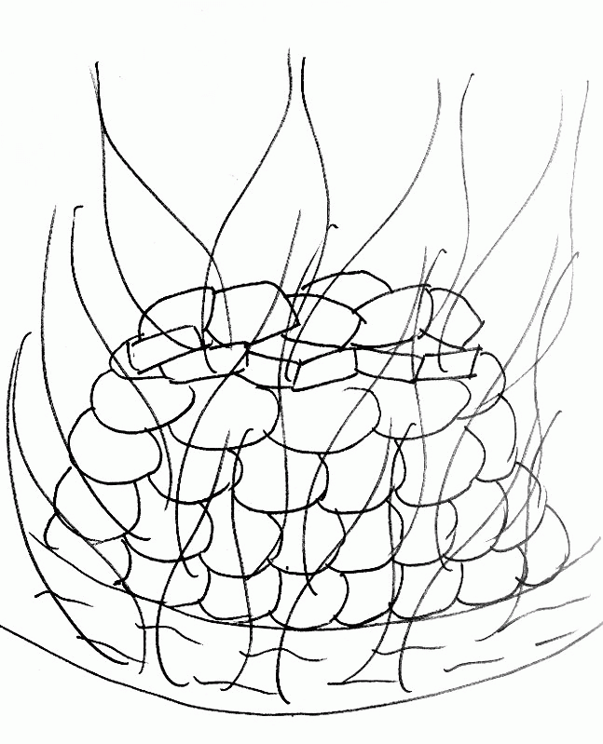
http://clipart-library.com/elijah-burning-altar-coloring-pages.html

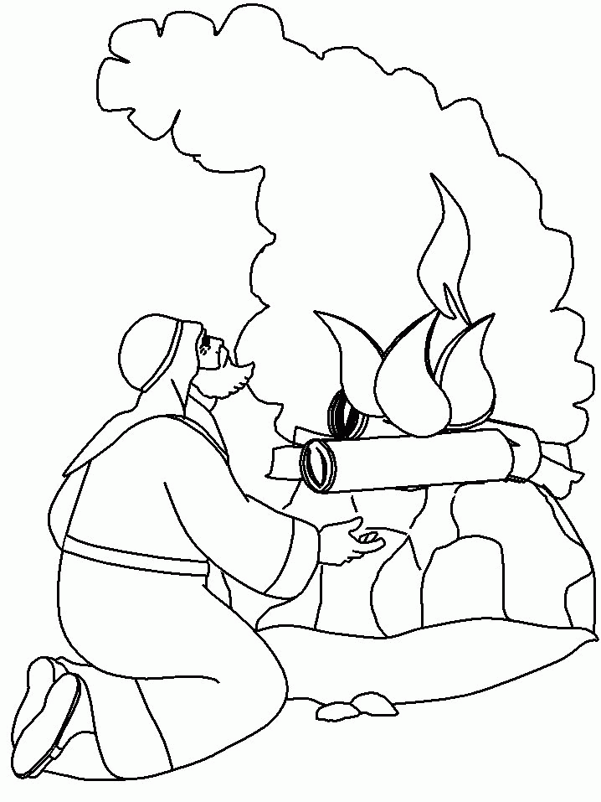
http://clipart-library.com/elijah-burning-altar-coloring-pages.html
