How many times is each word/phrase said during the service?

God/Lord/Jesus _______________________________________
Elijah _______________________________________
Rain/Cloud _______________________________________
Prayer/Prayer Life _______________________________________
Effective _______________________________________
Humble _______________________________________
Specific _______________________________________
Persistent _______________________________________
Expectant _______________________________________

What Scripture is the sermon from today? ___________________________________________

Definitions from Today’s Sermon
Prayer Life: what your prayer relationship with God is (do you expect your prayers to be answered, do you regularly talk to Jesus, do you pray for big things and small things, etc.)
Effective: Things happen when we pray
Humble: not proud, to lower oneself before someone greater
Persistent: don’t give up, keeps going no matter what
Expectant: looks for something to happen, expects one’s prayer to be answered

My Favorite Part of Service today was _____________________________________________________
Words/Things I didn’t understand:

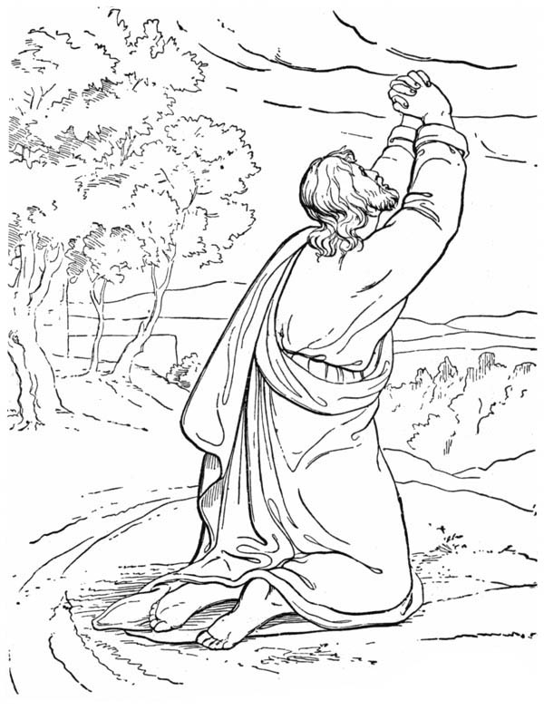

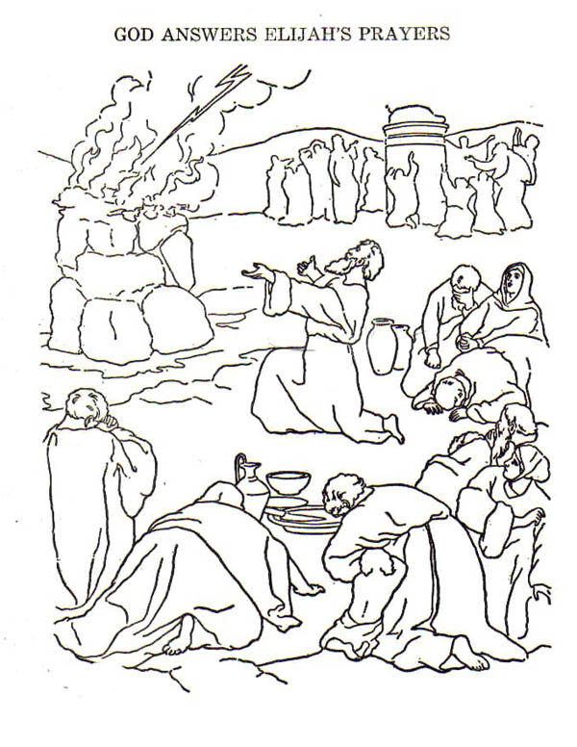

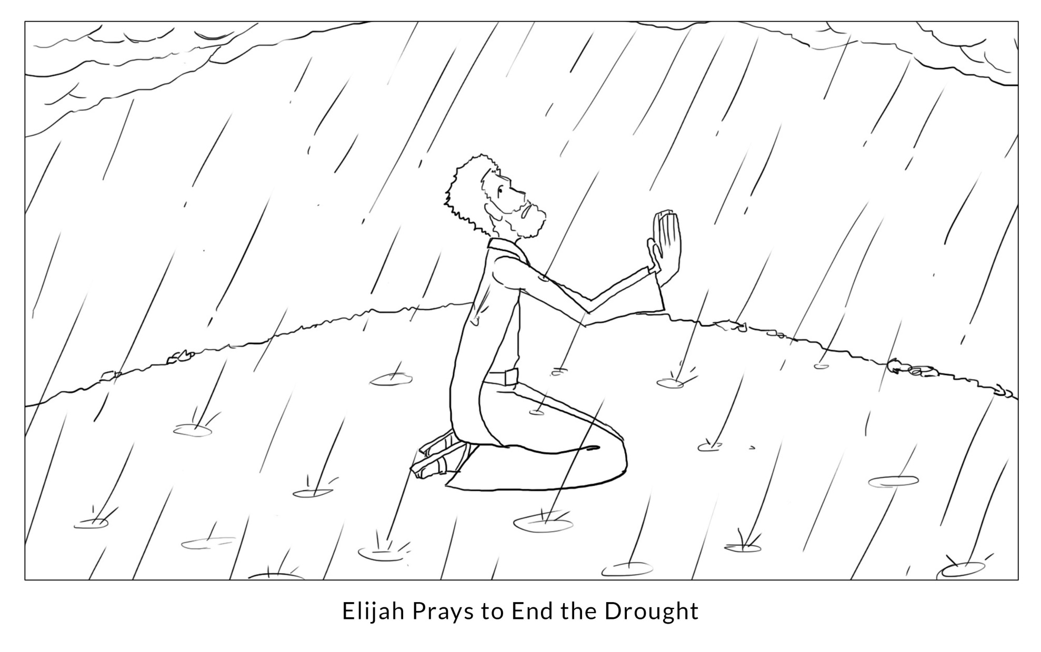

Lifespring Community Church Spring Grove, Il Gt Coloring Pages
