How many times is each word/phrase said during the service?
God/Lord/Jesus _______________________________________
Those People _______________________________________
Criticism/Criticize _______________________________________
Hurtful/Unjust _______________________________________

Definitions from Today’s Sermon
Criticism: the practice of correcting someone else’s mistakes or judging them based on certain standards
Constructive Criticism: Criticism that is meant to help someone improve; usually comes from people who love us and speak the truth in love to help us learn
Unjust Criticism: Criticism that is not meant to help us or spoken in love; usually hurtful

What Scriptures are mentioned in the sermon today? ________________________________________
_____________________________________________________________________________________
- Aaron and Miriam criticized ________________. Numbers 12:1-8
- People criticized _________________ for being a bad speaker. 2 Cor. 10:10
- Pharisees criticized _________________ for eating with sinners and healing on the Sabbath. Mark 2:16, Luke 13:14

- NEVER ______________ THE VALUE OF CONSTRUCTIVE CRITICISM.

- GOD, HELP ME KNOW WHEN TO _________________ TO CRITICISM.
- GOD, HELP ME KNOW WHEN TO __________________ INVALID CRITICISM.
- GOD, HELP ME OVERCOME MY OWN ________________ NATURE.

My Favorite Part of Service today was _____________________________________________________
Words/Things I didn’t understand:

How do we accept/respond to Constructive Criticism that is meant to help us?
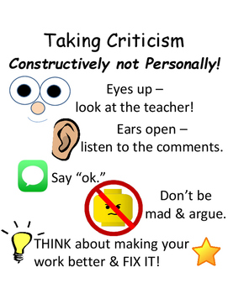

Look at Numbers 12 to answer these questions
